TEACHER PREPARATION IN TEXAS

CALL FOR NOMINATIONS:
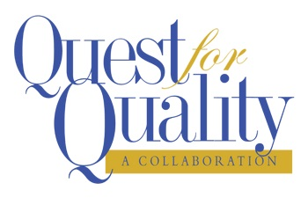
Quest for Quality

Exceptional K-12 School Partnerships Award

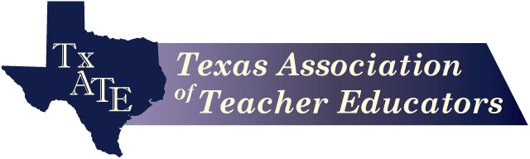
Texas Association of Teacher Educators
2019

Steps for Nominating
Quest for Quality Exceptional K-12 School Partnerships Award

TXATE extends the Call for Nominations of Exceptional K-12 School Partnerships in University Teacher Preparation Programs to Deans of Education and Deans of Arts and Sciences.

Deans or their designees should compile descriptions highlighting exceptional K-12 school partnerships in the university’s teacher preparation program and submit the
descriptions to TXATE designee, Karen Dunlap at kdunlap@twu.edu

The TXATE Awards Committee will review and validate nominations.

Successful nominations will include two components: a descriptive narrative of the partnership that includes the requirements listed in this document on page 4; and
artifacts that demonstrate strong evidence that support the narrative.

Nominations must be submitted by: September 15, 2019

For each nomination: Include the nomination information cover sheet on page 3, and submit the description of your university’s exceptional K-12 school partnerships in teacher preparation along with artifacts in an email with attached files to or as a package by mail to:

Karen Dunlap, kdunlap@twu.edu

Awardees will be celebrated at the CSOTTE conference 2019: October 27-29, 2019
Embassy Suites Dallas-Frisco Hotel, Spa & Conference Center

Quest for Quality

Exceptional K-12 School Partnerships

NOMINATING UNIVERSITY: _____________________________________

Submitted by: _____________________________________________________

Dean/Chair: ______________________________________________________

Date: _____________________

CONTACT INFORMATION:

Address: _________________________________________________________

_________________________________________________________________

Phone: _______________________ Email:______________________________

Nomination packages must be submitted by
September 15, 2019 to:

Karen Dunlap, kdunlap@twu.edu

Quest for Quality

Exceptional K-12 School Partnerships

TXATE invites universities to nominate Exceptional K-12 School Partnerships such as Induction Programs or Continuing Professional Development initiatives that have been developed and implemented through their university teacher preparation programs. These practices are critically important to the success of university-based teacher education programs. Not only do they provide teacher candidates with opportunities to engage in the theory and practice of teaching in context, but they also link universities, teachers, schools and communities in a common goal of improving learning for all children.
Partnerships may involve a single or multiple schools, school districts, and the university. They may take a variety of forms to reflect specific partnership activities and approaches with the goal of improving both teacher preparation and K-12 schools.
Nominations should describe exceptional K-12 school partnerships such as Induction Programs, or Continuing Professional Development initiatives that have been particularly effective in facilitating continuous improvement among all stakeholders. Partnership programs might include, but are not limited to:

- Induction Programs that provide support to beginning teachers
- Professional Development for K-12 teachers in content and/or pedagogy
- Curriculum Enhancement initiatives for both K-12 schools and teacher preparation
- University-School-Community Engagement programs

Descriptions should include:
  - Purpose and goals of the initiative
  - How the partnership is organized to engage all stakeholders
  - Activities undertaken to meet the goals
  - Explanation of the how the impact of the partnership is monitored and assessed.
Descriptions should be 1000 words (4 pages) maximum. In addition to the description, you
should include a few salient artifacts such as brochures or other publications, testimony from
partners, media that illustrate the activities undertaken through the partnership, or other
evidence of exceptional K-12 school partnerships.

